
NOVEMEBER 18th
11:00A.M - 2:00P.M.
This year’s family carnival includes:
- An assortment of Bouncy Houses
- Obstacle Course and Slides
- A variety of carnival games
- A pie eating contest! Who knows which faculty member will join the fun!
And don’t forget about the popcorn & cotton candy that is included! 

There will be a great craft fair with a variety of vendors just in time for your Holiday shopping!

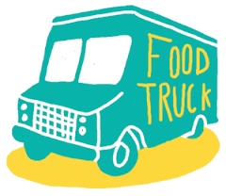There will be a variety of food trucks to meet everyone’s appetites.

Admission is $7.00 per person when purchased in advance
or
$10.00 at the door
(children under 3 are free)
***Max of $40.00 in ticket purchases per family***
All attendees must have a wrist band.

Look for wristband order forms to be coming home soon.

This event is hosted by Archway Arete PSO. If you have any questions about the carnival, being part of the craft fair, or volunteering, please contact Heather Bell at heatherbell1976@msn.com.

Grab your family and come join other Arete families for a great day of memories!

