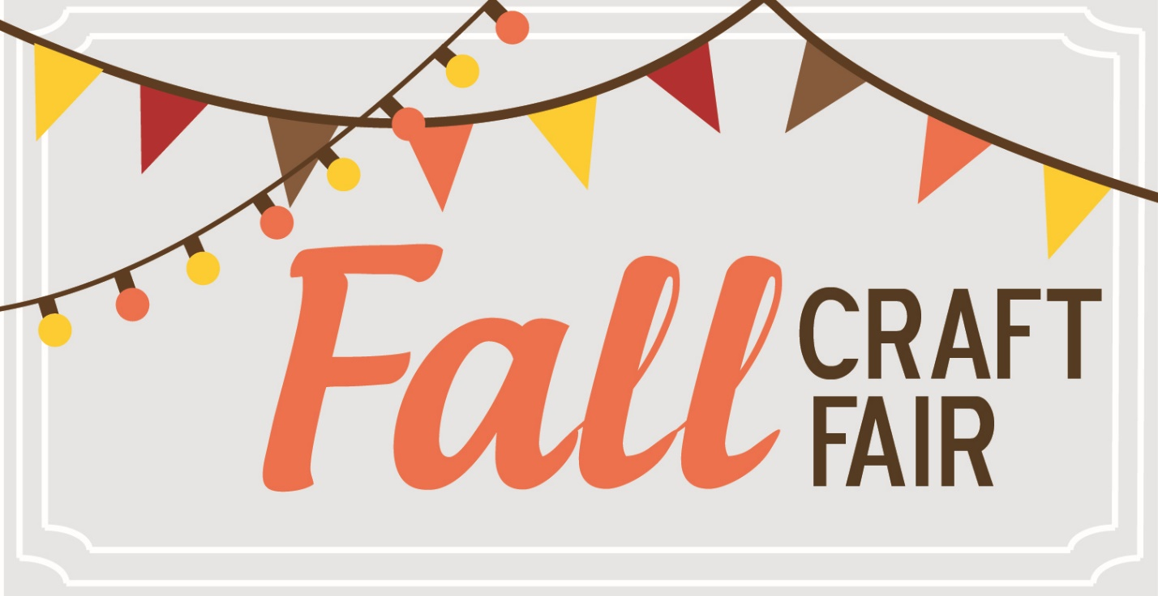
Saturday, November 18th from 11:00 a.m. – 2:00 p.m.


Are you a crafter or business owner?
Reserve your 10 x 10 space at the Fall Festival for only $40.00.
This will be just in time for the holidays!

We only allow one representative from each home based company to be represented.
(Example Mary Kay, Pampered Chef, Young Living Oils etc.).

Spaces are first come first served, so reach out to Heather Bell to receive your registration form right away.

If you have any questions or would like to register please contact Heather Bell at

heatherbell1976@msn.com or call /text 480-227-1599

